Curriculum Vitae

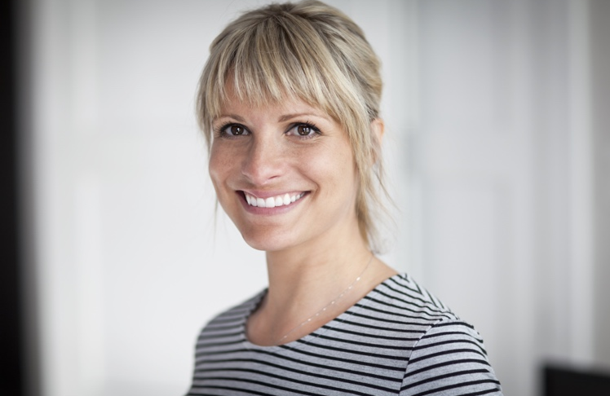

Sonja Mustermann

CONTACT

Address: Meierstraße 32
80799 München
Phone: 171. 123 456 789
E-Mail: kmustermeier@gmx.de

SKILLS

Teamwork
Project Management

LANGUAGES

English: Fluent
French: Basic

WORK EXPERIENCE

XX/20XX- XX/20XX
Company & Co. KGaA, Rosenheim
Applications developer
- Database administration and website design
- Built the logic for a streamlined ad-serving platform that scaled
- Educational institutions and online classroom management

XX/20XX-XX/20XX
Company & Co. KGaA, München
Analysis content
- Database administration and website design
- Built the logic for a streamlined ad-serving platform that scaled
- Educational institutions and online classroom management

EDUCATION

XX/20XX-XX/20XX
Rosenheim University of Applied Sciences
B.A. in Business Administration

XX/20XX-XX/20XX
Borcelle Business School
Certificate in Digital Marketing

EXPERTISE

Creativity
Critical Thinking
Negotiation

Burghausen, XX.XX.XXXX

